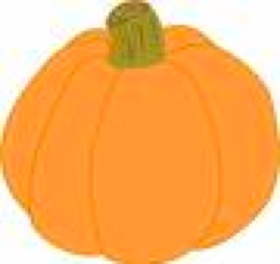



September 2011 Ms. Victor/Ms. Grace/Ms. Myung
Hot Topics!
We are off to a fabulous start in third grade!
Math - We have completed our first unit on time, money, number patterns, and math routines. We will now move onto addition and subtraction number stories (word problems), place value, and fact families to review +/-.

Social Studies – We are starting our “communities around the world” unit. The students have gathered information about their family heritage. We are beginning our history research by looking within ourselves. We will continue to study our heritage as well as the broader history of communities around the world.

Reading – We spend time reading in class every day as part of our reading workshop. We are working on our reading goals this month. We will continue to study the elements of a story and starting to learn about our characters in our fiction books using vocabulary to describe character traits.

Dates to Remember

Sept 29/30– School Closed


Writing Workshop Has Begun!
We have jumped right into Writing Workshop, a period of our day devoted entirely to writing. Before students began collecting entries, they decorated their writer’s notebooks with “maps” of their hearts to inspire them with meaningful topics for writing. We have begun with a unit that focuses on personal narratives. Students are learning strategies for coming up with ideas for stories that focus on small (but important) moments in their own lives.

Details

* Please check your child’s homework folder every day. You will find assignments on their homework log as well as any notes that need to be signed and returned to school.

*Please sign and return all tests the next day.

*Reminder: Students must read for at least 25 minutes at home, and fill out their reading logs.

The Pumpkin
Project Is Coming
At the middle of October, we will celebrate math and science while investigating an autumn mystery: How many seeds really are in a pumpkin?
Stay tuned for more…

